# **Maintaining state through multiple form**

Prepared: TrangNTT

Lab 10. Maintaining state through multiple form 1

10.1. Run the example in lecture slides 2

10.2. Preference selection using COOKIE 2

10.3. Preference selection using SESSION 4

10.4. Manage Login session 5

10.5. Exercise 7

## ***Run the example in lecture slides***

Using Hidden fields: Happy Harry’s Hardware Product Order: order.html, order2.php, order3.php.

Using Browser cookies: survey.html, setcookie.php, readcookie.php

PHP session: ordersession.php, sessions2order.php, sessions3order.php

## ***Preference selection using COOKIE***

### **PrefSelection.html**

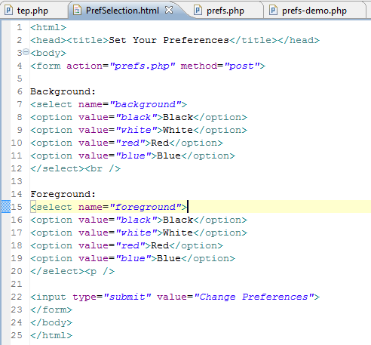

### **Prefs.php**

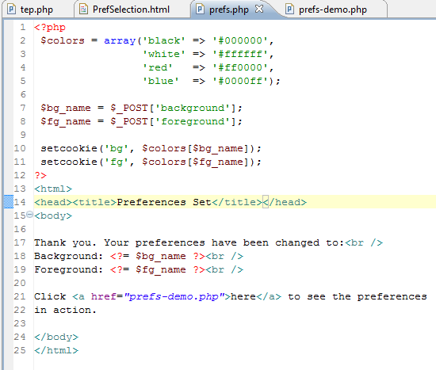

### **prefs-demo.php**

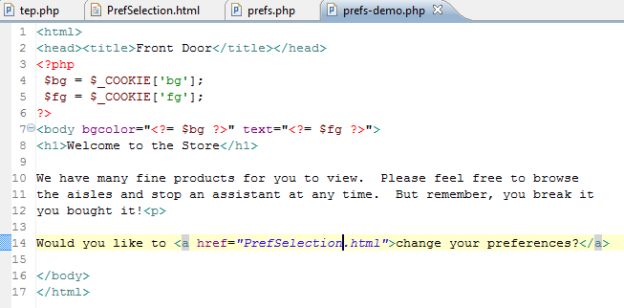

### **Result**

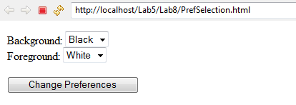

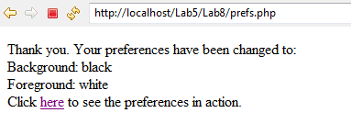

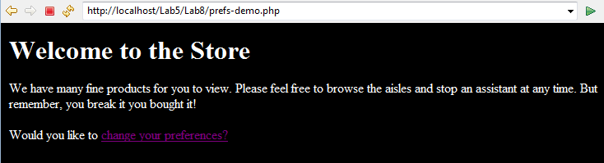

## ***Preference selection using SESSION***

Modify processing php files using session. The following is only the suggestion; you have to work around on it to do this exercise:

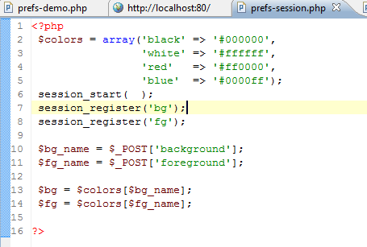

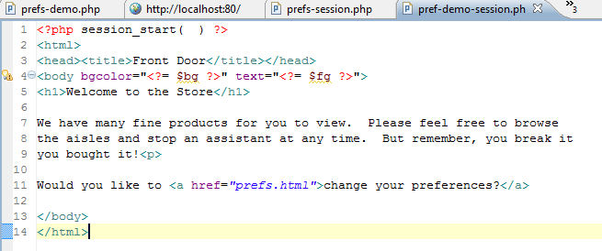

## ***Manage Login session***

### **Create database & table**

* Create a database named **Week9_GroupID_Ex2** (e.g., **Week9_Nhom10_Ex2**) then create table in this database named Users.

**CREATE TABLE Users (**

**UserName varchar(50),**

**Password varchar(30) NOT NULL,**

**DisplayName varchar(100) character set UTF8 NOT NULL,**

**Email varchar(50) NOT NULL,**

**PhoneNumber varchar(10)**

);

* Modify the Users table using phpMyAdmin: UserName is the PRIMARY KEY, Email is the UNIQUE KEY.

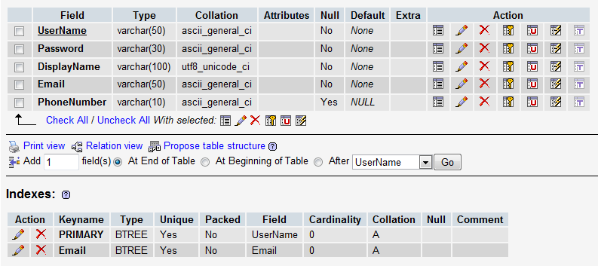

* Insert some data for Users table; note that DisplayName should be entered in Vietnamese.

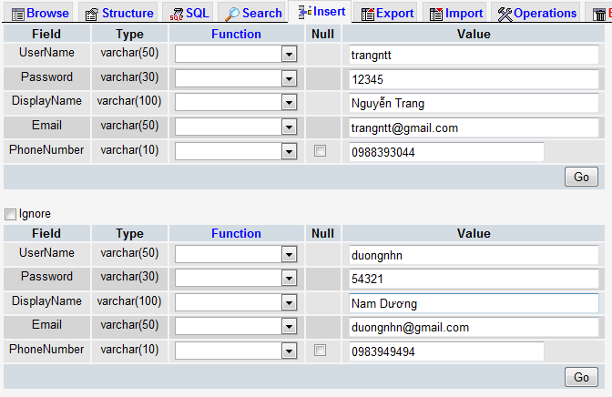

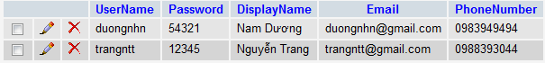

### **Create login.php**

* Allow users to enter his/her UserName and Password
* Check if the UserName and the Password are existed in the Users table or not
  + If both existed (login successfully), display Welcome page and the UserName should be written into session
  + If not matched (login fail), display Error in red color.

### **Create check_login.php to check if there is any UserName session. If No, redirect to the login.php page; otherwise stay at the current page.**

### **Modify the prefs-session.php and prefs-demo-session.php in 9.3**

* Includes check_login.php file to require the user log in before enter the page. Run to see the result.
* Add/modify heading 1 (h1) welcome to “HI $USERNAME, WELCOME TO THE STORE”, where $USERNAME is retrieved from the UserName session. Run again to see the result.

## ***Exercise***

Building a shopping cart application which allows users to choose products (Microsoft software like MSDNAA Program) then add them to cart. Then, users can view the cart; they can modify or delete a product in the cart.





